Project 3 Report

Christian Webber

May 7th, 2015

CptS 464, Section 1

Professor David Bakken

In Project 3, we were asked to implement a logical clock in a distributed system and to make a consistent global cut using the Chandy-Lamport snapshot algorithm. In implementing the distributed system, we were asked to use a common scenario, where Caesar must evenly distribute between his three generals an initially random amount of soldiers in each of the general’s camps.[1] A full copy of the scenario can be found in Appendix 1. In this report, an explanation of how to run the software, example outputs, a summary of the algorithms involved, and a list of challenges are provided.

Assuming one has access to the WSUCPTS464 projects on DeterLab, running the project is a simple process. First, the project (**cwebb-proj3**) must be swapped in. Once it has been swapped in, a user should login to each of the nodes (*Caesar*, *Brutus*, *Operachorus*, and *Pompus*) using ssh on 4 separate terminals.[2] Once logged into each of the nodes, simply run the correct bash file for the node in the following order:

**Pompus**: ./RunPompus.sh  
**Operachorus**: ./RunOperachorus.sh  
**Brutus**: ./RunBrutus.sh   
**Caesar**: ./RunCaesar.sh [Cut State]

The bash script will automatically install the necessary prerequisite (the **Go** programming language) onto the node if it hasn’t already been installed, although this process isn’t entirely automated so some user interaction will be required during the installation. The order of when *Pompus*, *Operachorus*, and *Brutus* are run does not particularly matter, but *Caesar* must be run last. An optional argument can be provided to specify the specific state (for Caesar) for the Cut to be made. If this argument is left out, a random number between 0 and 5 will be chosen instead. The most common cause of a run failing (if it hangs after sending a message) is that the IP addresses have changed (this happened once during testing, but on every other run it remained stable as long as the NS file remained stable. If necessary, the IP addresses can be changed by simply changing the value of the **Address** field in the respective settings file for the node. These IP addresses can be found by going onto the **Details** tab on the experiment’s page. The settings files are **setbrutus**, **setcaesar**, **setoperachorus**, and **setpompus**, for *Brutus*, *Caesar*, *Operachorus*, and *Pompus* respectively. However, no changes should be necessary for the functioning of the system. After the scenario is completed (each process will automatically end when Caesar says everyone is evenly distributed), a file will be made that will contain the information on the cut that was made during that run. This file is called **cutfile.txt**. A fully copy of all of the source code is provided in the folder packages with this report.

While the system is running, Caesar sends orders to his generals to attempt to evenly redistribute their troops. At the beginning of a run, each general has a random amount of troops of each type (Archers, Catapults, Cavalry, Infantry, and Spearmen) between 1 and 100. This value is divided by 3 to determine the amount of soldiers each general should have, and a remainder value is also calculated to determine how the leeway each number can have for an individual general in regards to extra troops. By the end of the run, each general should have approximately the same amount of troops available in each category. An example of the initial and final states of the system can be found below.

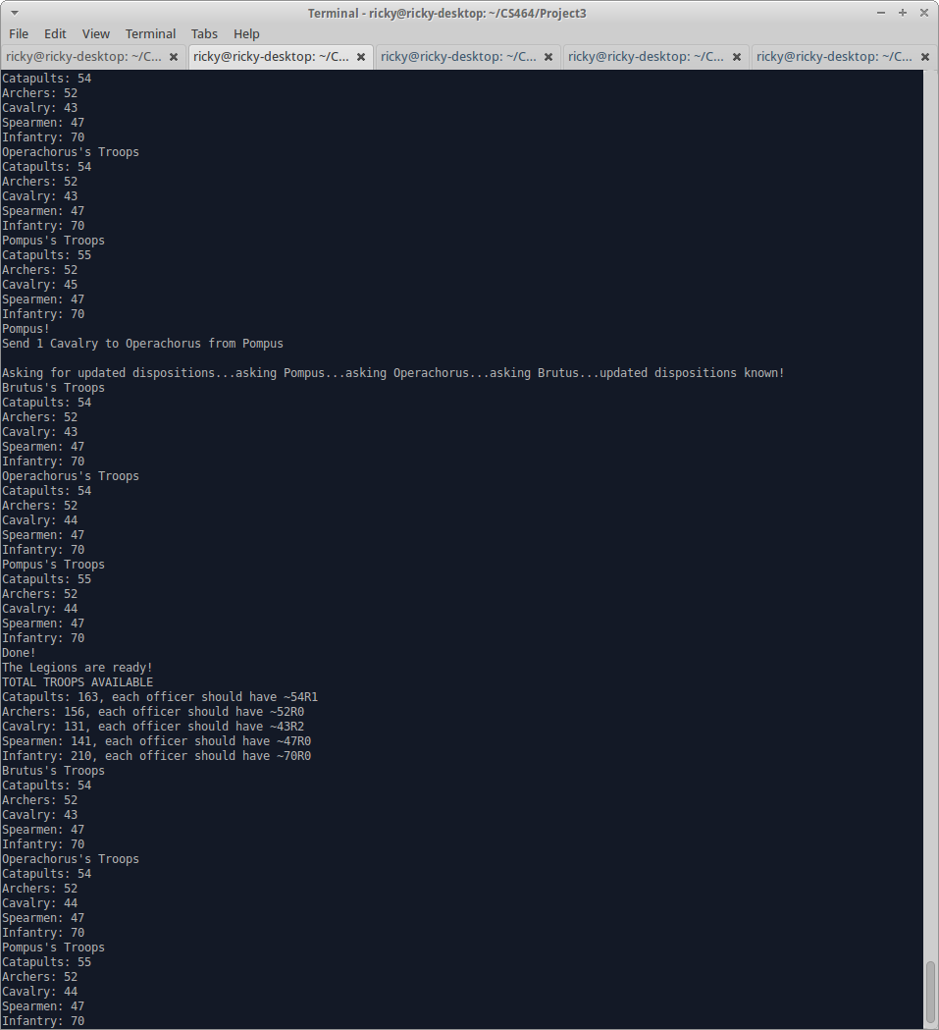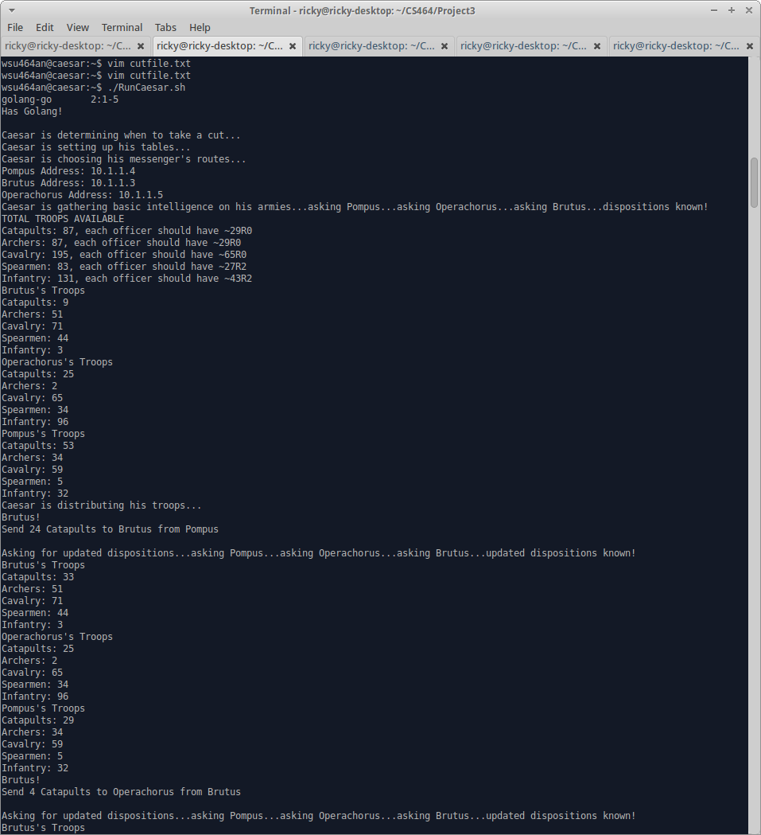

Figure 1 - Final State of System

Figure 2 - Initial State of System

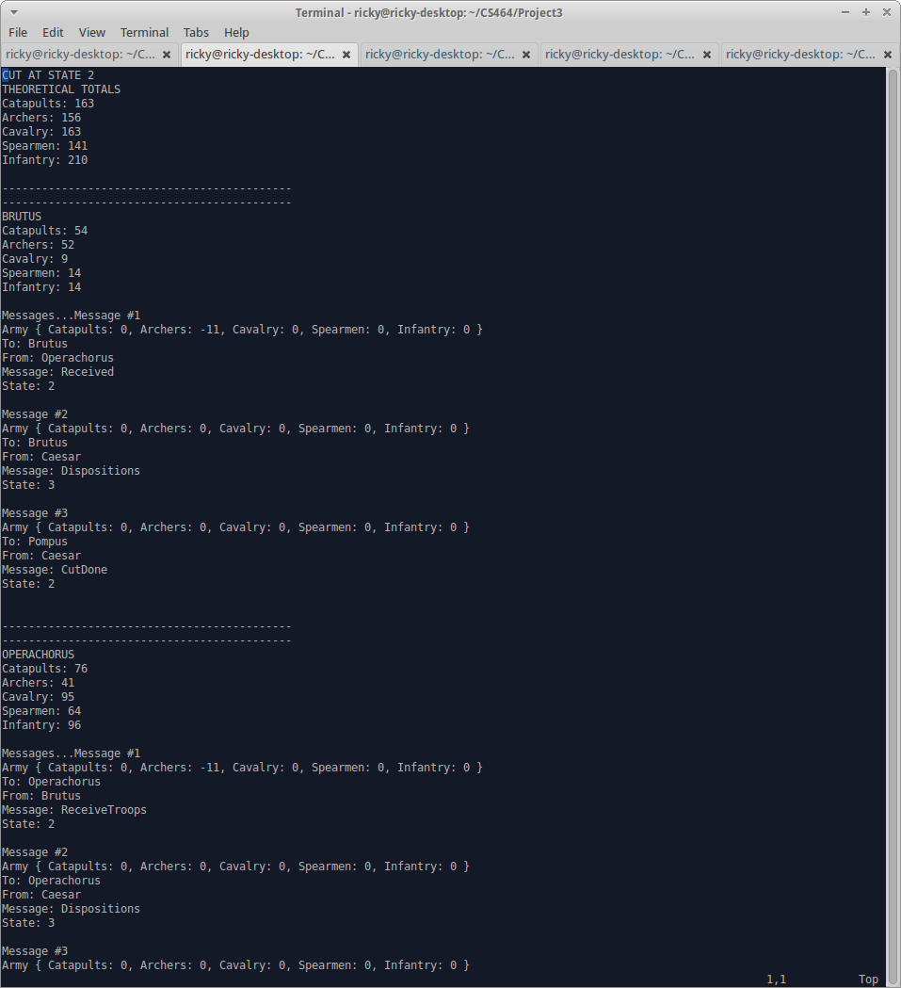At some point during the scenario, a “cut” will be taken of the system (for a basic description of the algorithm for the cut, view appendix 2). This snapshot will show the global state of the entire system at a single “moment,” and will be exported to an external file, **cutfile.txt**, to allow it to be easily viewed at any moment. Examples of a snapshot are displayed below.

Figure 3 - Cut Log Part 1

Figure 4 - Cut Log Part 2

As can be seen in the log files, the total numbers of each category of unit for each general sums up to the estimated totals (displayed at the top). Additional screenshots are provided in the folder and in Appendix 3.

The single biggest challenge that was experienced during this project was unfamiliarity with the **Go** programming language. Although it is similar to a combination between **Python** and **C**, both of which I have experience with, it still took a while to become familiar enough with it to create the programs for this project. This also limited me somewhat in creating the programs in particularly well-designed ways. I went through 3 complete rebuilds before finally settling on one that allowed me to complete the programs, and partial rebuilds of major sub-systems occurred along the way. I was also limited in my abilities to use some more advanced libraries and techniques due to this unfamiliarity, as well as the strange lack of a while loop in **Go**. Another challenge that I experienced was in using DeterLab. Initially it was confusing to get around, as DeterLab’s provided tutorials are fairly dense. While this is good once you’re used to getting around the system, a lighter weight tutorial is necessary for the basics. Luckily, this challenge was solved, mostly thanks to the help and basic tutorials provided by Jeremy. I feel that it would have been better if we had had more experience with using DeterLab before this project.The final challenge was the algorithm for the scenario. For some reason, it took much longer than it should have to come up with a half-way decent algorithm to redistribute the troops. Although I know better ones now, and would have been able to use them if I was more familiar with Go or was using a language I was more familiar with, this remained a significant early challenge for completing the project.

Overall, the project proved to be an interesting and fun challenge. While I might wish for some changes to the project (an easier scenario so that I’d have had more time to focus on the algorithm, for example), it was still a decent project. I also feel like I have learned a lot about distributed systems, much more than I did in any previous assignment, as well as in making cuts to a distributed system.

**Appendix 1**

**Taken from the CptS 464/564 Project 3 Specifications by Professor David Bakken:**

“Caesar summoned three of his favorite generals Brutus, Pompus, and Operachorus to share his latest strategy to attack the Gaul village. “This time, we’ll attack them from four directions”, said Caesar. The generals agreed and all four armies began their march towards the village right away. Upon arriving near the village, the generals realized that the village is surrounded by four hills. So, Caesar ordered each army to set camp on each of the hills and wait for further orders. Caesar is a highly methodical person and wants all generals to be in-sync. Roman generals are known for their excellent vector clock skills so Caesar plans to use it to synchronize his armies. As his first order, Caesar sends a message to all three generals to report him back with the count of their army units – catapults, archers, cavalry, spearmen, and infantry. He wants each army 1 to have an equal number of units. Those days, the only form of communication was to use a human messenger. Messengers are usually the fastest soldiers in the army but they are not reliable. Each general obeys Caesar’s order and sends their respective unit counts in a single message. Thus assume trustworthy generals. Upon receiving the unit counts from each general, Caesar calculates how many units should be relocated to and from each army and instructs the respective generals. For example, one such relocation command could be “Brutus, send 30 infantry to Pompus”. Each general carries out the order he receives by redeploying the units mentioned in their message.”

**Appendix 2**

**Taken from the CptS 464 Chapter 14 slides by Professor David Bakken:**

Snapshot algorithm

•By Chandy and Lamport [1985]: determine global states   
•Goal: record a set of process AND channel states such that it is consistent (not strongly consisten) •Assumptions   
 • Neither channels nor processes fail   
 • Channels are uni-directional and FIFO ordered   
 • Graph of processes and channels strongly connected (path between any 2 processes)   
 • Any process may initiate the snapshot at any time   
 • Processes don’t need to freeze/lock: continue normal operations  
• Main ideas   
 • Terms: incoming channels and outgoing channels for pi   
 • Each process records its state, and for each incoming channel, set of messages sent to it   
 • For each channel, process records msgs that arrived after its last recorded state and before sender recorded state   
 •I.e,. Record state at different times but account for messages transmitted but not yet received (these are part of the channel stat)   
 • Use distinguished marker messages   
 •Tell receiver to save state   
 •Way to determine which messages go in channel state   
 •To initiate the algorith, process acts like it received a marker message

Chandy and Lamport’s ‘snapshot’ algorithm   
Marker receiving rule for process pi   
On pi ’s receipt of a marker message over channel c:   
 if (pi has not yet recorded its state) it   
 records its process state now;   
 records the state of c as the empty set;   
 turns on recording of messages arriving over other incoming channels;   
 else   
 pi records the state of c as the set of messages it has received over c since it saved its state.   
 end if   
Marker sending rule for process pi   
After pi has recorded its state, for each outgoing channel c:   
 pi sends one marker message over c (before it sends any other message over c).

**Appendix 3**

1. David Bakken, *CptS 464/564 Project #3 Implementation of “logical clock” and making “consistent global cut”*, (2015), 2
2. **Brutus**: Brutus.cwebb-proj3.WSUCPTS464.isi.deterlab.net

   **Caesar**: Caesar.cwebb-proj3.WSUCPTS464.isi.deterlab.net

   **Operachorus**: Operachorus.cwebb-proj3.WSUCPTS464.isi.deterlab.net

   **Pompus**: Pompus.cwebb-proj3.WSUCPTS464.isi.deterlab.net